A Project Report

on

TRAFFIC MANAGEMENT USING INTELLIGENT TECHNIQUES



Bachelor of Technology

IN

ARTIFICIAL INTELLIGENCE

BY

SYED FAWAZ AYAZI MOHD MUZAMMIL

FACULTY NUMBER-22AIB116 FACULTY NUMBER-22AIB306

Under The Guidance of

MRS. NADIA SIDDIQUI

INTERDISCIPLINARY CENTRE FOR ARTIFICIAL INTELLIGENCE

ZAKIR HUSSAIN COLLEGE OF ENGINEERING AND TECHNOLOGY ALIGARH MUSLIM UNIVERSITY, ALIGARH(202002)



Declaration

Dated………….

The work presented in the project entitled “Traffic Management Using Intelligent Techniques” being submitted to the Interdisciplinary Centre of Artificial Intelligence, Zakir Husain College of Engineering and Technology, Aligarh Muslim University Aligarh, during the even semester of the session 2023-24, is our original work. We have neither plagiarized nor submitted the same work for the award of any undergraduate project.

Date:

Place: (Signature)

Syed Fawaz Ayazi

(Signature)

Mohd Muzammil



Dated………….

Certificate

This is to certify that the project report entitled ”Traffic Management Using Intelligent Techniques” being submitted by “Syed Fawaz Ayazi” and “Mohd Muzammil”, in fulfilment of the requirements of the minor project submission for B.Tech 2nd  year in Artificial Intelligence during the session 2023-24, to the Interdisciplinary Centre of Artificial Intelligence, Zakir Hussain College of Engineering and Technology, Aligarh, is a record of candidate’s own work carried out by them under our supervision and guidance.

Mrs. Nadia Siddiqui

Assistant Professor

Interdisciplinary Centre for Artificial Intelligence

ZHCET, AMU, Aligarh

**Table Of Contents**

**Abstract** 5

**Acknowledgements** 6

**Acronyms** 7

**List of Figures** 8

**1 Introduction 9**

**1.1 Motivation** 9

**1.2 Objectives and Scope** 9

**2 Literature Review 10**

**2.1 Convolutional Neural Network(Deep Learning)** 10

**2.2 Object Detection** 10

**2.3 Object Tracking** 10

**3 Implementation 11**

**3.1 Dataset Description** 11

**3.2 Transfer Learning Techniques** 12

**3.3 Object Detection** 13

**3.4 Object Tracking** 14

**3.5 Management** 15

**4 Results 16**

**4.1 Final Model** 18

**4.2 Flow Chart** 19

**5 Conclusion and Future Work 19**

**References 20**

**Abstract**

This project, titled " Traffic management Using Intelligent Techniques" focuses on improving traffic management, and solving complex traffic scenarios by using advanced deep learning techniques. Utilizing YOLOv4 and Convolutional Neural Networks (CNNs), the project aims to develop a sophisticated system for real-time traffic detection and management. The primary goals are to analyse traffic patterns, identify congestion, and deploy strategies for dynamic traffic flow management. Extensive datasets, including CCTV footage from the New Zealand Transport Agency, serve as the foundation for training and evaluating the system. Core elements of the project include object detection with YOLOv4, object tracking using the SORT algorithm, and real-time communication via Twilio for alert notifications. The results indicate a promising potential for enhancing urban traffic efficiency, reducing congestion, and increasing road safety. Future enhancements will aim to scale the system, incorporate advanced algorithms like YOLOv8, and expand its capabilities to include pedestrian and cyclist traffic management, integration with smart city technologies, and environmental monitoring, thus offering a comprehensive solution to modern urban traffic management challenges.

**Acknowledgement**

First, we want to thank our parents for their endless support and encouragement throughout this big task. They have always been there to boost our confidence when we needed it most.

We worked hard on this project, but it wouldn't have been possible without the kind help and support of many individuals and organizations. We are truly grateful to all of them.

We are especially thankful to Nadia Siddiqui Ma’am for her guidance and support. She provided us with the necessary information and helped us every step of the way. Her encouragement and supervision were crucial in completing this project.

We appreciate her for helping us approach this project with creativity, confidence, and enthusiasm. This project is the result of her hard work and dedication.

We also want to thank the members of Zakir Hussain College of Engineering and Technology for their cooperation and encouragement. Their support was essential in helping us finish this project.

Finally, we thank our colleagues for their help and ideas. Their willingness to assist us made a big difference.

Syed Fawaz Ayazi

Mohd Muzammil

May 2024

**Acronyms**

YOLO You Only Look Once

COCO Common Objects in Context

CNN Convolutional Neural Network

FCN Fast Convolutional Network

IOU Intersection over Union

CSP` Cross Spatial Network

SORT Simple Online Realtime Tracking

**List of Figures**

Figure.1 The total number of instances of a vehicle of particular in our training dataset.

Figure. 2 The sample of our training dataset demonstrating categories diverse environment patterns and road patterns.

Figure. 3 Principle of transfer learning

Figure. 4 Demonstration of some object detection results

Figure. 5 SORT flow chart

Figure. 6 Demonstration of some of object tracking results

Figure. 7 Alert message on mobile phone via SMS

Figure. 8 Final Model

Figure. 9 Flow Chart

**1 Introduction**

This chapter provides a detailed introduction to the project "Road Segmentation and Object Detection using Deep Learning" and highlights the key points of the project. The main point discussed is the motivation for the project, the objectives and scope, and the organization.

* 1. **Motivation**

This project is dedicated to employing advanced algorithms, including YOLO and CNN network models, for traffic detection and management . The diverse and often chaotic traffic conditions in India pose significant challenges for effective traffic management. However, this also presents an opportunity to develop innovative solutions that can optimize traffic flow, reduce congestion, and enhance overall road safety. The primary motivation behind this endeavour is to explore the application of advanced algorithms for traffic detection and management. By doing so, we aim to contribute to the development of solutions that can effectively address the unique traffic challenges faced in our daily lives, ultimately leading to smoother traffic flow and improved road safety.

* 1. **Objectives and Scope**

The main objective of this project is to develop a comprehensive system for traffic detection and management, leveraging state-of-the-art algorithms and technologies. This system aims to analyse traffic patterns, detect congestion, and implement strategies for efficient traffic flow management. To achieve this, the project will utilize extensive datasets containing real-world traffic data.

The scope of the project encompasses the development of algorithms for real-time traffic detection, congestion identification, and dynamic traffic management. Additionally, the project will explore the integration of emerging technologies such as machine learning and artificial intelligence to enhance the effectiveness of traffic management strategies. The evaluation of the system will involve assessing its performance under different traffic scenarios and identifying areas for improvement.

1. **Literature Review**
   1. **Convolutional Neural Network(Deep Learning)**

Deep Learning is an Artificial Intelligence (AI) technique that has emerged as an effective tool for analysing big data. It uses complex algorithms and artificial neural networks to train machines so that they can learn from experience, classify and recognize data or images just like a human brain does. Within Deep Learning, a Convolutional Neural Network or CNN is a type of artificial neural network, which is widely used for image or object recognition and classification. Deep Learning thus recognizes objects in an image by using a CNN. CNNs are playing a major role in diverse tasks or functions like image processing problems, computer vision tasks like localization and segmentation, video analysis, to recognize obstacles in self-driving cars, as well as speech recognition in natural language processing. As CNNs are playing a significant role in these fast-growing and emerging areas, they are very popular in Deep Learning.

* 1. **Object Detection**

Object detection is a computer vision technique for locating instances of objects in images or videos. Object detection algorithms typically leverage machine learning or deep learning to produce meaningful results. When humans look at images or video, we can recognize and locate objects of interest within a matter of moments. The goal of object detection is to replicate this intelligence using a computer.

Here's how object detection typically works:

Localization: Object detection algorithms first locate potential objects within an image by predicting bounding boxes that tightly enclose them. These bounding boxes represent the spatial extent of the objects.

Classification: Once objects are localized, the algorithm assigns class labels to each bounding box, indicating the category or type of object present. This step involves analysing the content within the bounding boxes to determine what each object is.

* 1. **Object tracking**

Object tracking is a computer vision application where a program detects objects  and then tracks their movements in space or across different camera angles. Object tracking can identify and follow multiple objects in an image. For example, a football recording studio could follow where a ball is in a photo.

Object detection and tracking are both computer vision algorithms. Object detection algorithms identify objects in an image or video and their location in the media. This can be an algorithm on its own, or used to enable object tracking. Object tracking algorithms, on the other hand, follow objects over frames in a video.

* 1. **Management Techniques**

Traffic management is a critical area of urban planning and public safety, encompassing a range of techniques and technologies aimed at optimizing traffic flow and reducing congestion. Traditional methods such as traffic signal control and road lane adjustments have long been employed to manage traffic density and improve road safety. Advanced approaches leverage intelligent transportation systems (ITS), which integrate real-time data collection and analysis to dynamically adjust traffic signals, provide route recommendations, and manage incidents. More recently, the advent of machine learning and deep learning techniques has revolutionized traffic management. These technologies enable the prediction of traffic patterns and congestion through the analysis of large datasets, facilitating proactive management strategies. Algorithms such as YOLO (You Only Look Once) for real-time object detection and SORT (Simple Online and Real-time Tracking) for vehicle tracking are being utilized to monitor traffic conditions and optimize flow. Additionally, the integration of communication platforms like Twilio enhances real-time alert systems, ensuring that traffic managers can respond swiftly to emerging issues. Collectively, these diverse techniques contribute to a more efficient, adaptive, and safer urban traffic environment.

1. **Implementation**
   1. **Dataset Description**

We obtained our dataset from research paper 'Towards Real-time Traffic Flow Estimation using YOLO and SORT from Surveillance Video Footage' itself which is CCTV image and video dataset from the New Zealand Transport Agency (NZTA), Christchurch, New Zealand. As a case study, we selected a busy road namely “West along Yaldhurst Rd from Curletts Rd” in Christchurch CBD. The image datasets that we obtained by breaking video dataset into frames were used to train YOLOv4. The training dataset includes 1964 frames with their annotated data, so total image file size was of 3928. The classes present in our dataset was 5 namely Car, Motorcycle, Bus, Truck, Van.

For testing purpose and for counting algorithm we used real-time traffic flow video of India that we got from the YouTube.

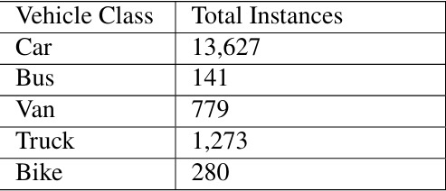

Fig.1 Total Instances of vehicles of different class

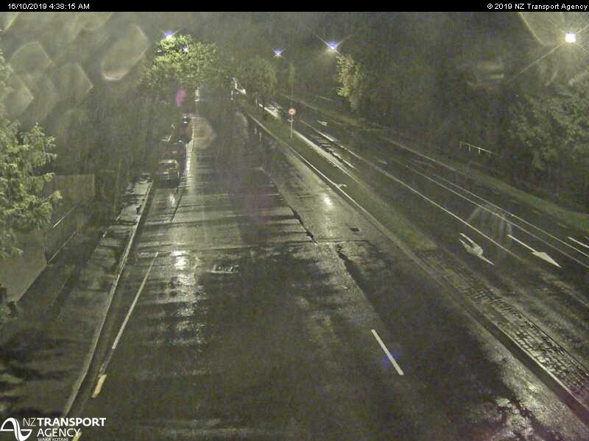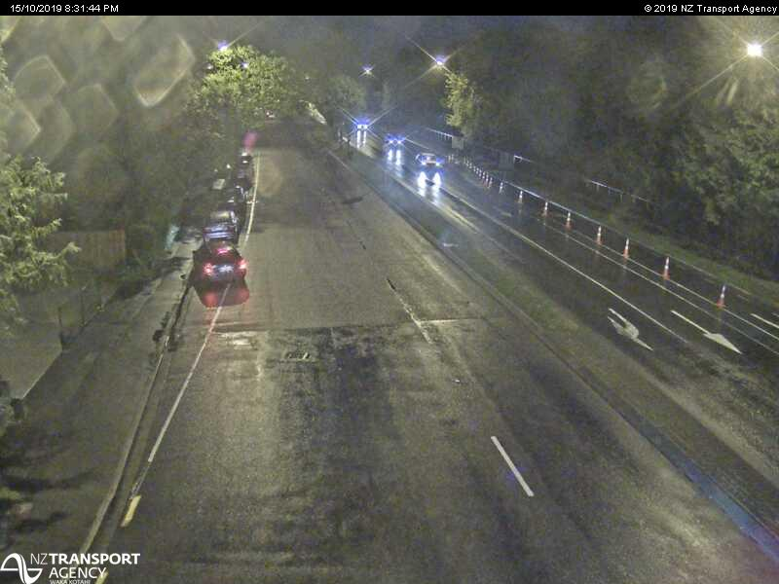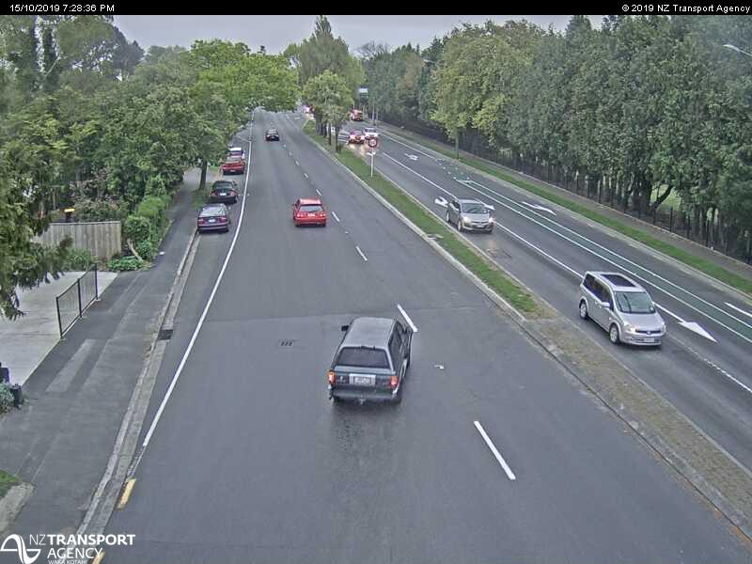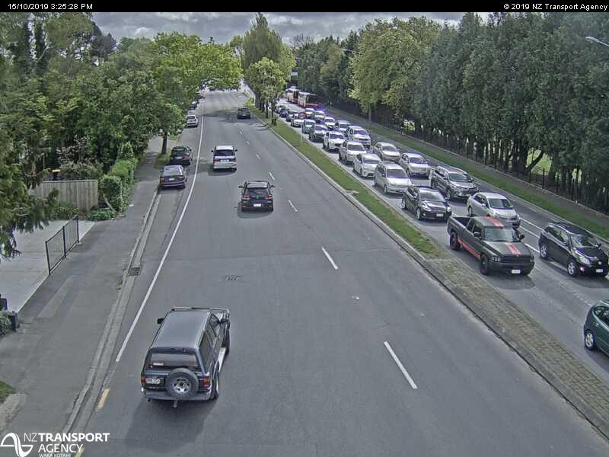

Fig.2 Sample images from the dataset

* 1. **Transfer Learning Techniques**

In transfer learning, the knowledge of an already trained machine learning model is applied to a different but related problem. For example, if you trained a simple classifier to predict whether an image contains a backpack, you could use the knowledge that the model gained during its training to recognize other objects like sunglasses. With transfer learning, we basically try to exploit what has been learned in one task to improve generalization in another. We transfer the weights that a network has learned at “task A” to a new “task B.”

The general idea is to use the knowledge a model has learned from a task with a lot of available labeled training data in a new task that doesn't have much data. Instead of starting the learning process from scratch, we start with patterns learned from solving a related task. Transfer learning is mostly used in computer vision and natural language processing tasks like sentiment analysis due to the huge amount of computational power required.

It has become quite popular in combination with neural networks that require huge amounts of data and computational power.

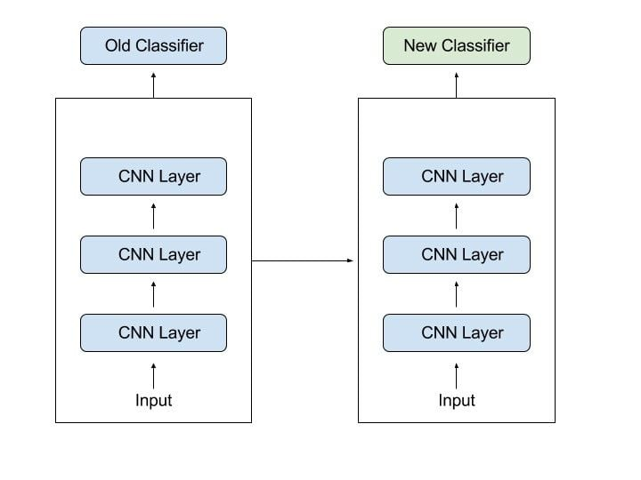

Fig.3 Principle of Transfer Learning

* 1. **Object Detection**

Object detection is an important task in computer vision that involves identifying and localizing objects in an image or video. We used, Yolov4 for detection of objects that are in our class namely Car, Truck, Bus, Van, Bike.

The cutting-edge object identification model YOLOv4 (You Only Look Once version 4) offers real-time performance with exceptional accuracy. On top of the basis laid by the earlier YOLO models (YOLOv1, YOLOv2, YOLOv3), it offers a number of enhancements and optimizations.

Important YOLOv4 features:

For real-time applications, YOLOv4 strives to strike a balance between detection accuracy and inference speed.

The backbone network, CSPDarknet53, divides the feature map into two halves to enhance learning capabilities and minimize processing.

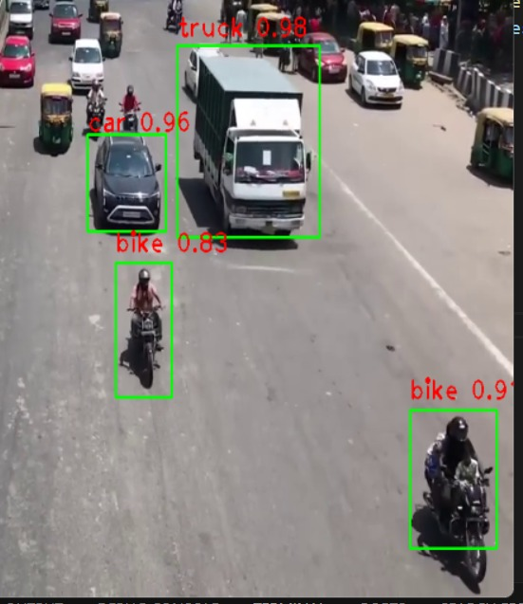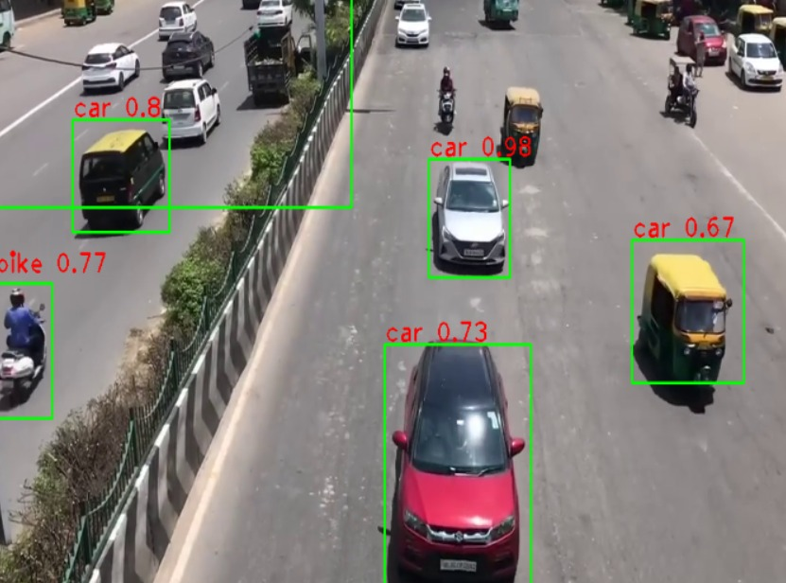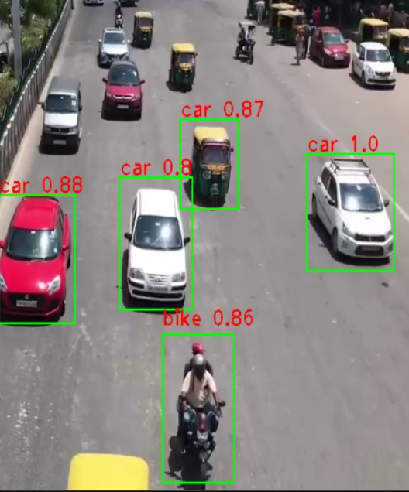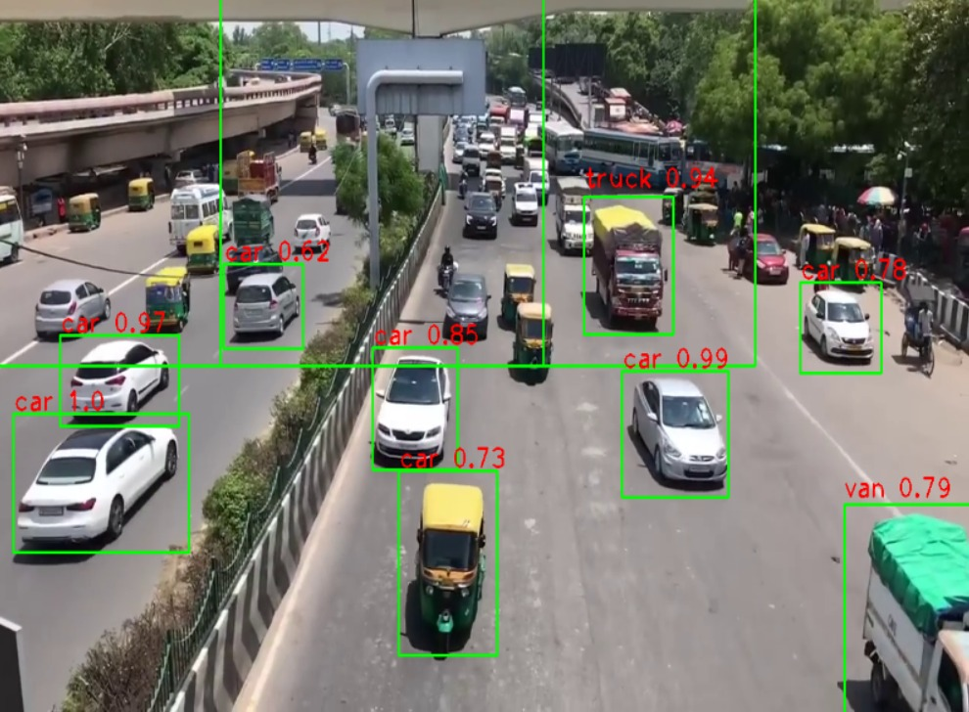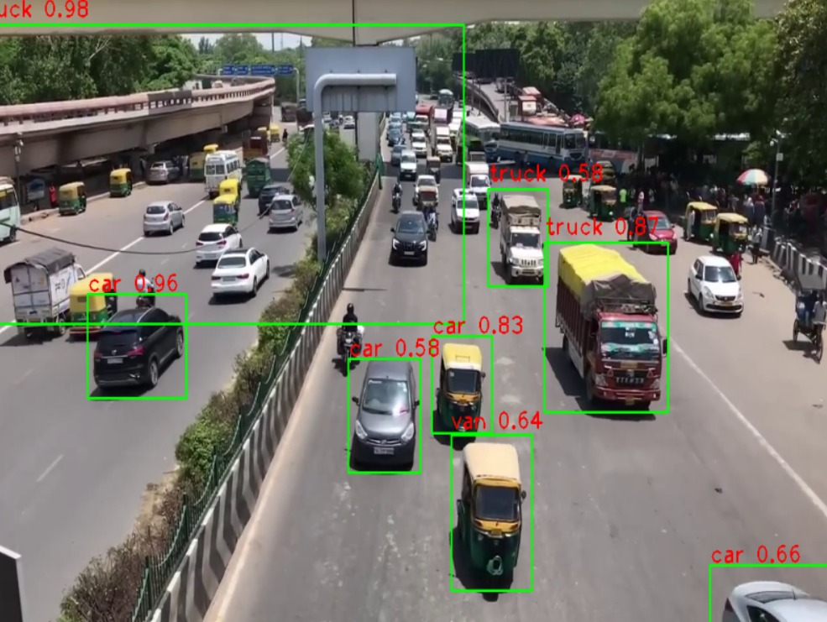

Fig.4 Some object detection results

* 1. **Object Tracking**

Object tracking is the process of locating an object in a video stream and following its movement over time. Object tracking has numerous applications, including surveillance, robotics, and autonomous vehicles. In this section, we will provide an introduction to object tracking and discuss the Simple Online and Real-time Tracking (SORT) algorithm.

The Simple Online and Real-time Tracking (SORT) algorithm is a simple and efficient algorithm that can track multiple objects simultaneously by associating detections across frames. SORT is a combination of several techniques, including Kalman filtering, data association, and intersection over union (IOU) metric. SORT uses the Kalman filter to predict the object’s location in the next frame and associates the detection with the predicted location using the IOU metric. SORT then updates the Kalman filter’s state using the associated detection and repeats the process for the next frame.

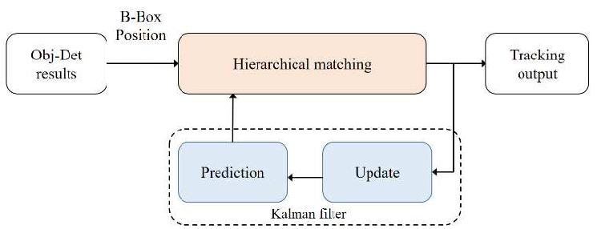

Fig.5 SORT algorithm flow chart

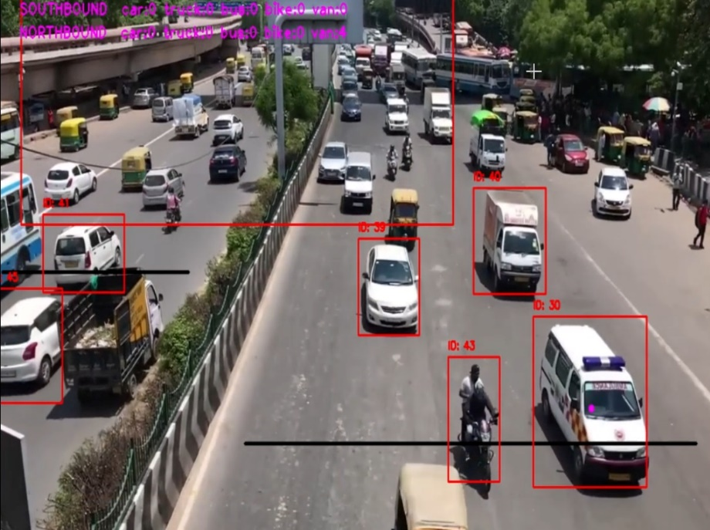 Fig.6 Some tracked vehicle results

* 1. **Management**

In our traffic management system, we have integrated the Twilio messaging platform to enhance real-time communication by sending alert messages whenever traffic congestion is detected. The system employs processing of live traffic camera feeds and identifies assesses traffic flow, vehicle density, and movement patterns. When congestion is detected based on predefined thresholds, the system automatically triggers SMS alerts via Twilio to notify traffic managers and relevant authorities. This timely notification system allows for prompt intervention and effective traffic management, thereby reducing delays and improving overall traffic flow.

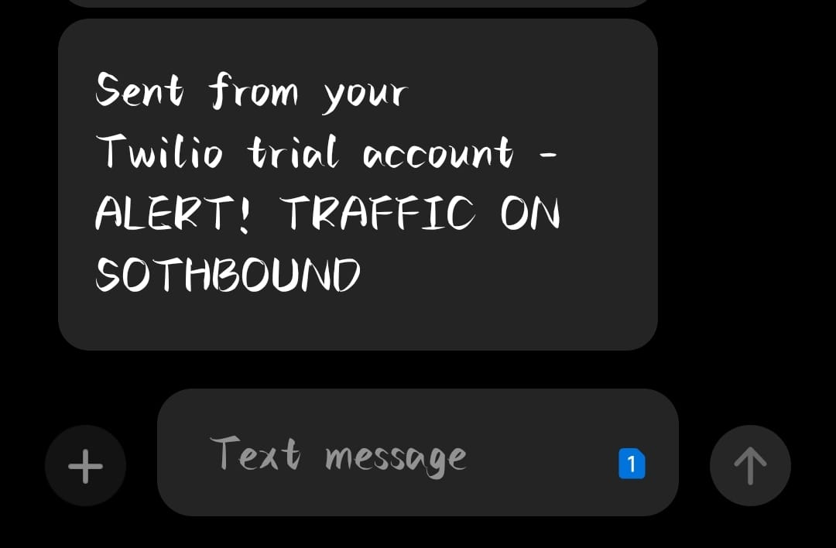

Fig.7 Alert message on mobile phone via SMS

1. **Results**
   1. **Final Output**

The final output of our model encompasses three key components: bounding box generation, class detection, and object tracking. Utilizing deep learning algorithms like YOLOv4 for detection and classification, the model accurately identifies objects and assigns them class labels. Incorporating the SORT algorithm for object tracking ensures consistent monitoring of object movement across frames. Together, these functionalities provide a comprehensive solution for real-time traffic management.

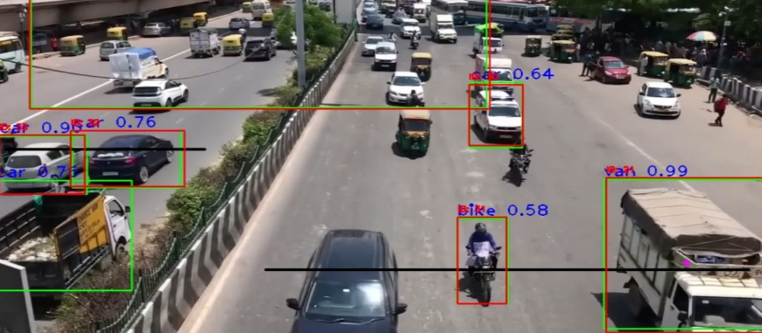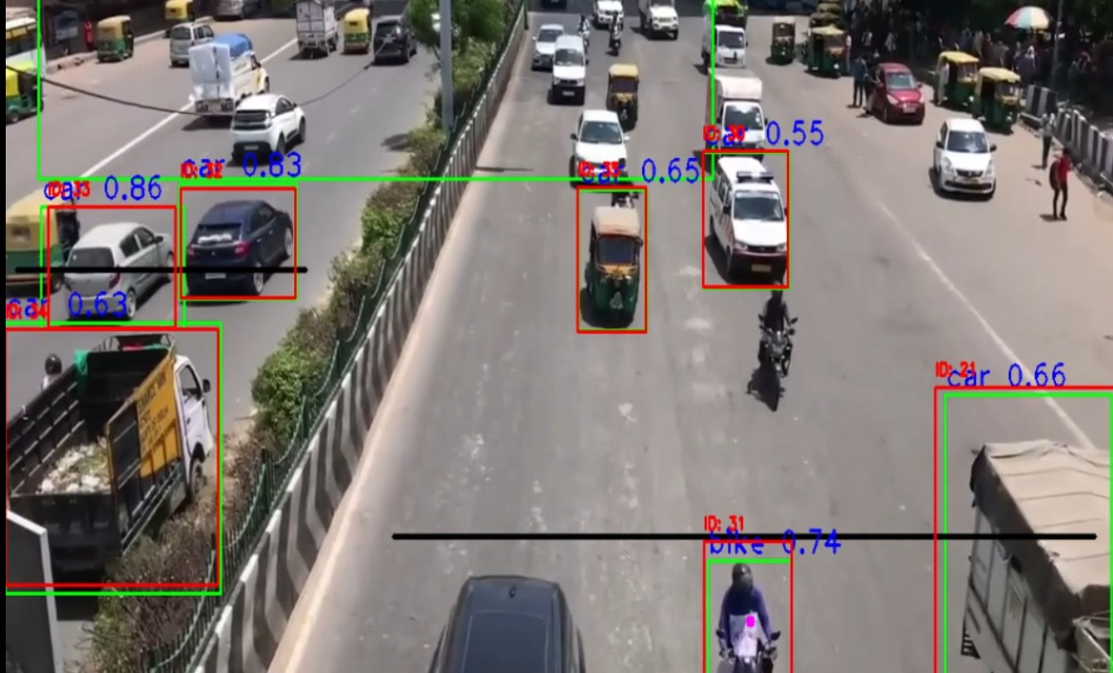

Fig. 8 Final Output

* 1. **Flow Chart**

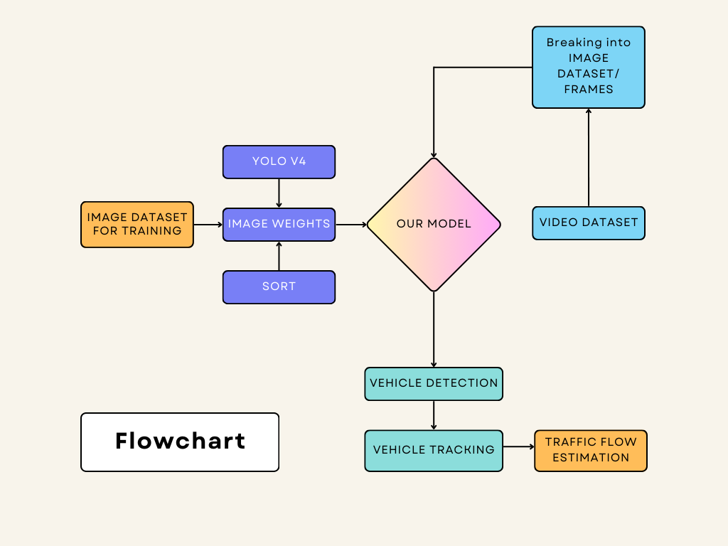

Fig.9 The proposed model

1. **Conclusion and Future Work**
   1. **Conclusion**

In conclusion, this project demonstrates the significant potential of computer vision techniques in enhancing traffic management for our cities. By leveraging the YOLOv4 model for accurate and real-time object detection, and the SORT algorithm for efficient tracking of vehicles, our system effectively monitors and analyzes traffic conditions. The integration of the Twilio API for sending alert messages ensures that relevant authorities are promptly informed about congestion, enabling swift and effective response measures. The combination of these advanced technologies results in a robust traffic management system that can significantly improve urban traffic flow, reduce congestion, and contribute to safer and more efficient city environments. This project highlights the transformative impact of integrating computer vision and communication tools in addressing the complex challenges of urban traffic management.

* 1. **Future Work**

The future potential of this traffic management project is substantial, with numerous opportunities for enhancement and expansion. By scaling the system to cover more urban areas, we can create a more comprehensive solution for traffic monitoring. Utilizing advanced algorithms like YOLOv8 and predictive analytics will enhance accuracy and help foresee congestion before it occurs. Integrating with broader smart city infrastructures, such as intelligent traffic lights and dynamic road pricing, will contribute to more adaptive traffic management. Providing real-time data to the public through mobile apps or websites can inform drivers and reduce congestion by offering alternative routes. Additionally, extending the system to manage pedestrian and cyclist traffic and incorporating autonomous vehicle networks can further optimize urban transportation. Including environmental sensors for monitoring air quality and noise levels will support strategies for healthier urban living, while prioritizing emergency vehicle management will improve public safety. Collectively, these advancements promise to make urban traffic systems more efficient, safer, and environmentally friendly.

**References**

1. Algiriyage, Nilani & Prasanna, Raj & H Doyle, Emma & Stock, Kristin & Johnston, David & Punchihewa, Minura & Jayawardhana, Santhoopa. (2021). Towards Real-time Traffic Flow Estimation using YOLO and SORT from Surveillance Video Footage.wards Real-time Traffic Flow Estimation using YOLO and SORT from Surveillance Video Footage
2. Sama Aswith Reddy-Vehicle Counting And Traffic Congestion Detection Using YOLOv3 - IJFMR Volume 5, Issue 4, July-August 2023. DOI 10.36948/ijfmr.2023.v05i04.4616.
3. Phursule, R. ., Lal, D. ., Waghere, S. ., Mughni, M. A. ., Ransubhe, S. ., & Shiralkar, C. . (2023). Enhancing Traffic Flow Using Computer Vision Based - Dynamic Traffic Light Control and Lane Management. International Journal on Recent and Innovation Trends in Computing and Communication, 11(7s), 386–391. https://doi.org/10.17762/ijritcc.v11i7s.7014
4. Jegatheesan, Divya; Arumugam, Chandrasekar Intelligent Traffic Management Support System Unfolding the Machine Vision Technology Deployed using YOLO D-NET.International Journal of Intelligent Engineering & Systems . 2021, Vol. 14 Issue 5, p25-34. 10p.
5. https://youtu.be/xFz6wfsUxdM?feature=shared